Control Systems Engineering (EC 3104) MATLAB Assignment Codes:

4) ***Code:***

rlocus([0 32 0],[1 2 32]);

***Figure:***

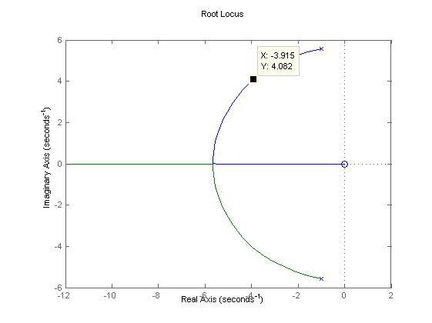

9) Code:

p1=[-1.74,-0.03879];

p2=[0,-1,-10,-11.511,-0.005];

cof1=poly(p1);

cof2=poly(p2);

rlocus((426.32*cof1),cof2); %[1,1.77879000000000,0.0674946000000000;]

cof3=(426.32*cof1); cof4=[1,22.5160000000000,136.733555000000,(115.793105000000+(1*426.32)),(0.575550000000000+(426.32*1.77879000000000)),(426.32*0.0674946000000000)];

step(cof3,cof4);

Figure 1: Root Locus of the required transfer function: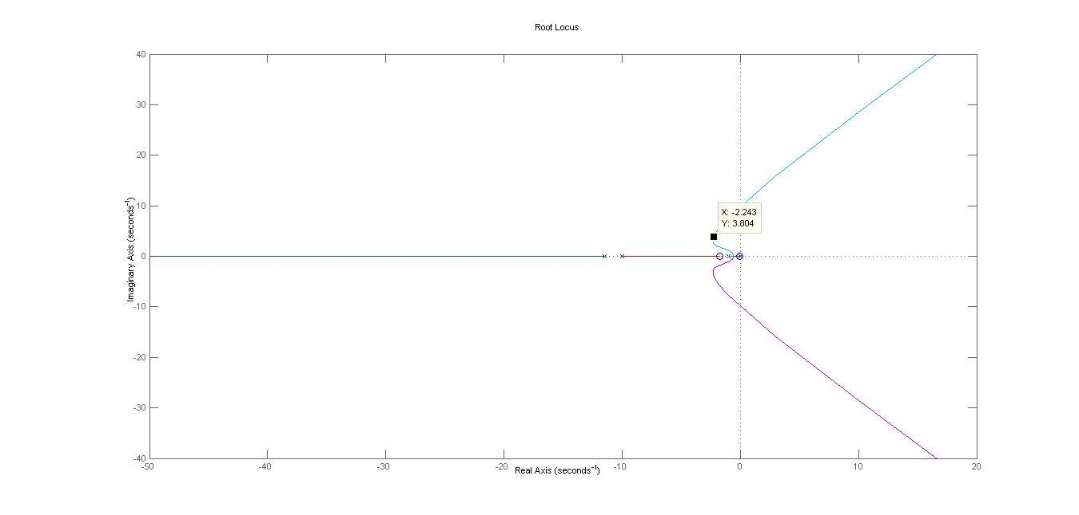 Figure 2: Unit Step Response of the required transfer function: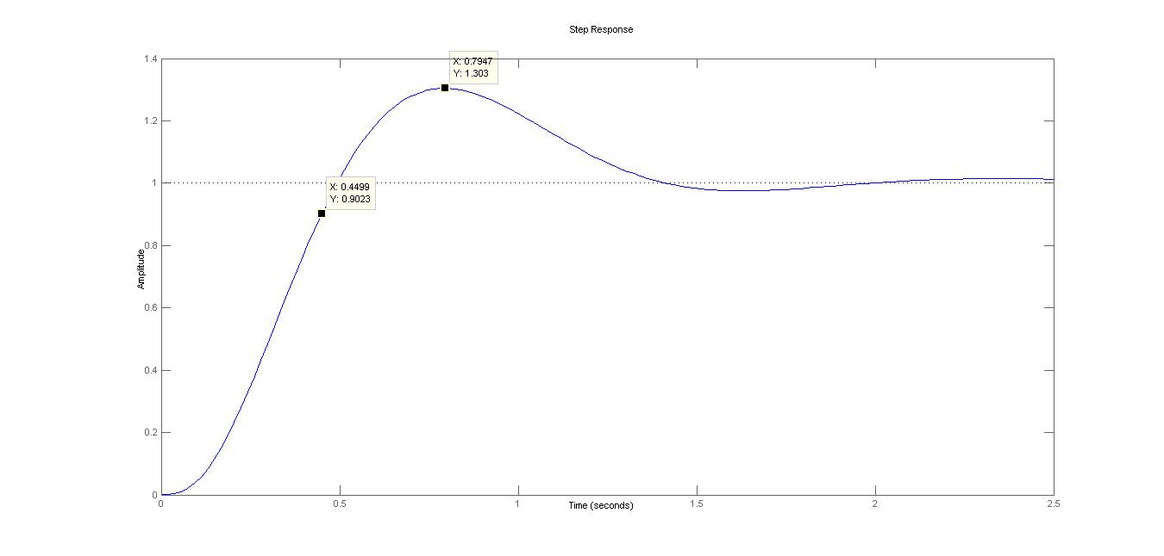

22) Code:

r1=[-0.29,-0.035,-18.001];

r2=[0,-10,-1.0707,-0.005,-41.099];

%bode([100 (100*0.29)],[1.0000 11.0701 10.7010 0]);

coef1=poly(r1);

coef2=poly(r2);

bode((527.58*2.2831*coef1),coef2);

Figure 1: Bode Plot of the transfer function with lead-lag compensation: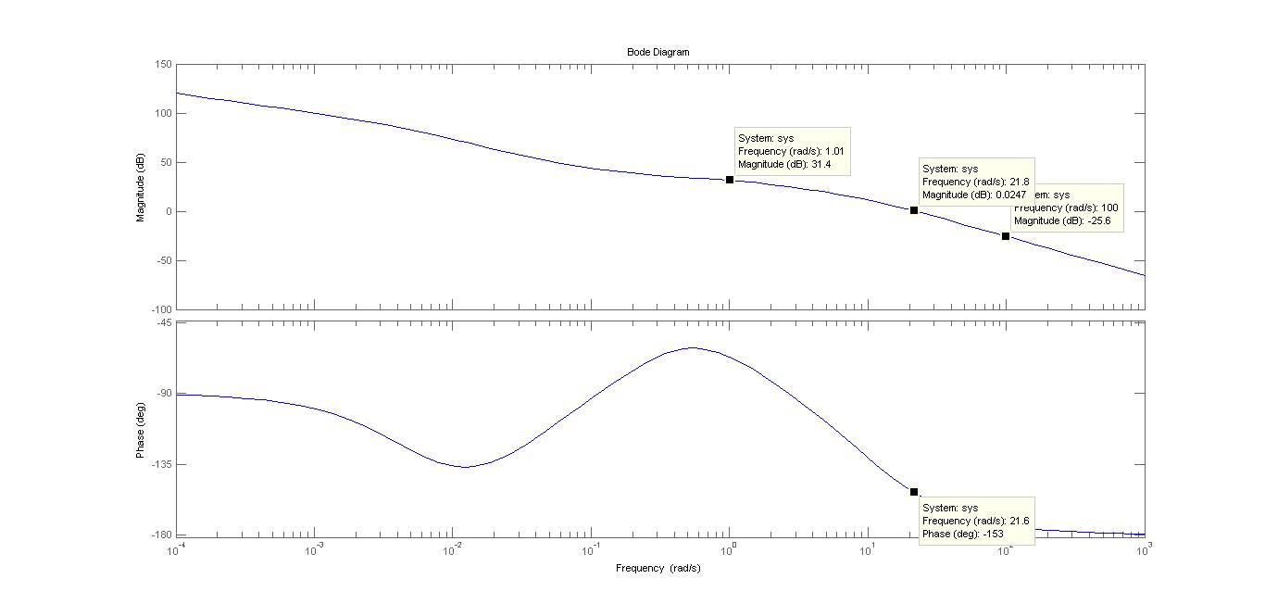

Figure 2: Bode Plot of the transfer function with an extra lead compensation: